**AUTOMATIC SANITIZER**

**ABSTRACT:**

In the time of pandemic, it has been important to every one to take care of themselves. In this process, sanitization is the most crucial thing which one person has to follow. To make the sanitization very easy and also touchless I came up with the idea of automatic sanitizer. This automatic sanitizer consists of an ultrasonic sensor which calculates the distance and depending on the result it will activate the servo motor that compresses the sanitizer bottle to push out the sanitizer liquid. This is completely touch free and also easy to operate.

**DESCRIPTION:**

1. **ARDUINO/UNO R3**

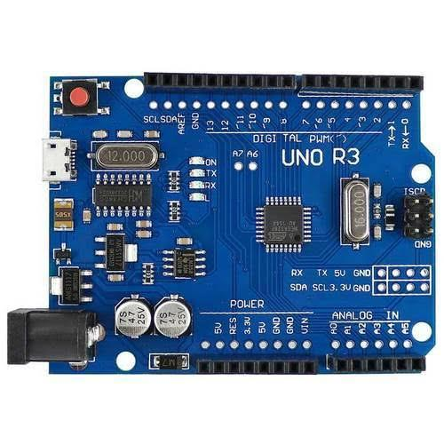

Arduino is an open-source platform for hardware and software companies. By using this we can create many digital devices which are working models in the industry to replace and reduce human involvement in that particular field.

It contains a microcontroller chip on it named ATMEGA328, which has been manufactured by the company called ATMEL. Arduino has many versions. We used the R3 version.

**SPECIFICATIONS**:

* Has 14 input/output digital pins
* It contains 6 analog pins
* 16 mega Hz crystal oscillator
* USB connection for dumping the code
* Power jack
* 5v output, ground (for external sensors and devices)
* A reset button for running the code from starting.
* Used embedded c as a coding language.
* It has UART (universal asynchronous receiver and transmitter) as communication between devices.

1. **SERVO MOTOR:**

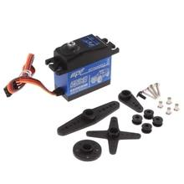

A servomotor is a [rotary actuator](https://en.wikipedia.org/wiki/Rotary_actuator) or [linear actuator](https://en.wikipedia.org/wiki/Linear_actuator) that allows for precise control of angular or linear position, velocity and acceleration. It consists of a suitable motor coupled to a sensor for position feedback. It also requires a relatively sophisticated controller, often a dedicated module designed specifically for use with servomotors.

Servo Motors are not a specific class of motor, although the term servomotor is often used to refer to a motor suitable for use in a [closed-loop control](https://en.wikipedia.org/wiki/Closed-loop_control) system.

Servo Motors are used in applications such as [robotics](https://en.wikipedia.org/wiki/Robotics), [CNC machinery](https://en.wikipedia.org/wiki/CNC_machine) or [automated manufacturing](https://en.wikipedia.org/wiki/Automated_manufacturing).

1. **ULTRASONIC SENSOR:**

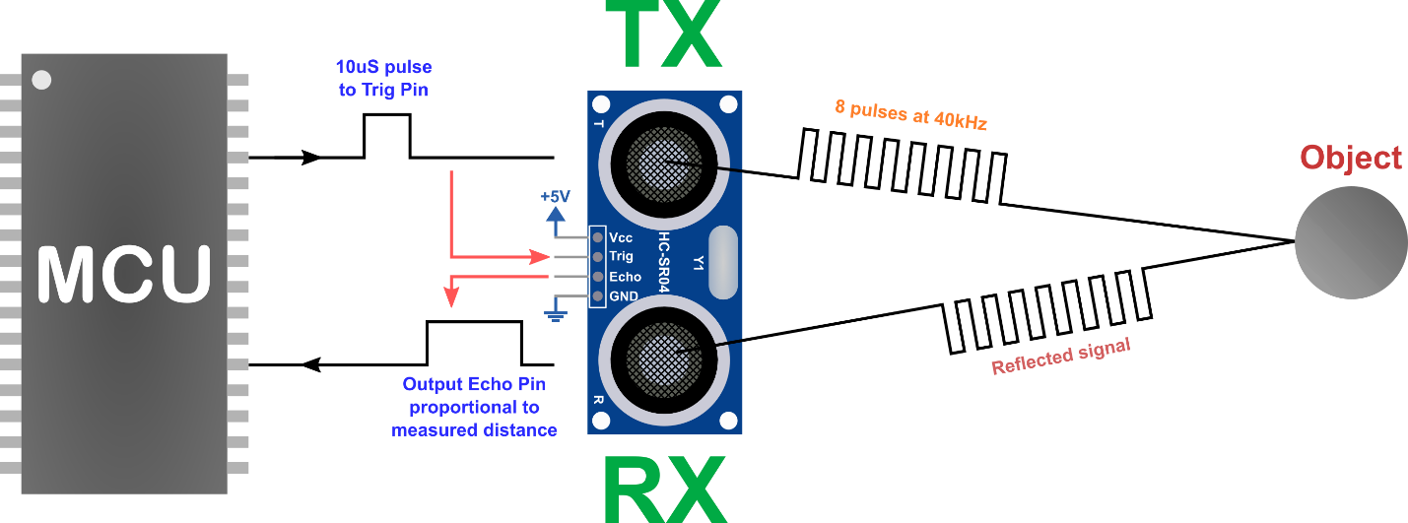

An ultrasonic sensor is an electronic device that measures the distance of a target object by emitting ultrasonic sound waves, and converts the reflected sound into an electrical signal. Ultrasonic waves travel faster than the speed of audible sound (i.e., the sound that humans can hear). Ultrasonic sensors have two main components: the transmitter (which emits the sound using piezoelectric crystals) and the receiver (which encounters the sound after it has travelled to and from the target).

In order to calculate the distance between the sensor and the object, the sensor measures the time it takes between the emission of the sound by the transmitter to its contact with the receiver. The formula for this calculation is [D = ½ T x C](https://www.arrow.com/en/research-and-events/articles/ultrasonic-sensors-how-they-work-and-how-to-use-them-with-arduino) (where D is the distance, T is the time, and C is the speed of sound ~ 343 meters/second). For example, if a scientist set up an ultrasonic sensor aimed at a box and it took 0.025 seconds for the sound to bounce back, the distance between the ultrasonic sensor and the box would be:

D = 0.5 x 0.025 x 343

or about 4.2875 meters.

1. **12V & 9 V BATTERY:**

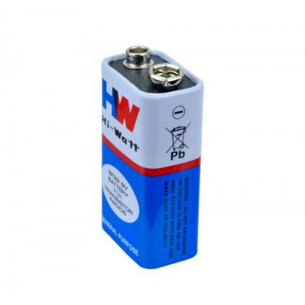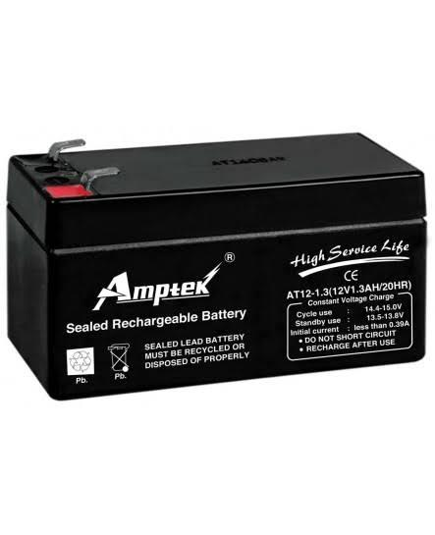

12V is the power supply which is given to the l298n motor driver. This motor driver supplies power to motors and as well as to Arduino (but we used another 9v battery to give power to the Arduino). 12V is power full battery so we connected a switch by avoiding direct connection.it can be rechargeable after each use.

1. **JUMPING WIRES**

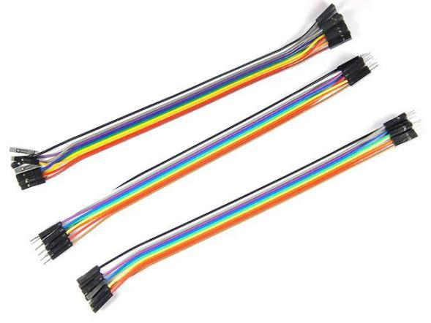

These are the modes of the connection and communication from one device to another.

These are of three types:

Male to male type

Female to female type

Male to female type

NOTE: These wires cannot withstand high power supplies(>12v).

1. **SWITCHES:**

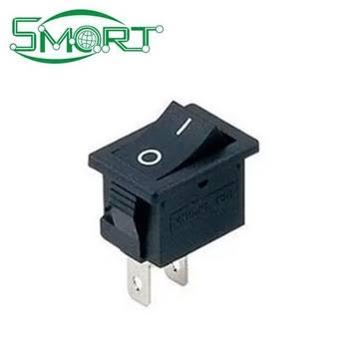

These switches are used to avoid direct connections and power loss.

**CODING PART:**

#define trigpin 12

#define echopin 11

#include <Servo.h>

Servo myservo1; // create servo object to control a servo

// twelve servo objects can be created on most boards

int pos = 0; // variable to store the servo position

float distance,duration;

void setup(){

Serial.begin(9600);

pinMode(trigpin,OUTPUT);

pinMode(echopin,INPUT);

myservo1.attach(9);

}

void loop() {

digitalWrite(trigpin,LOW);

delay(500);

digitalWrite(trigpin,HIGH);

delayMicroseconds(100);

digitalWrite(trigpin,LOW);

duration = pulseIn(echopin,HIGH);

distance = duration/29.1;

Serial.println("Distance:");

Serial.println(distance);

delay(100);

if(distance < 10)

{

myservo1.attach(9);

delay(100);

{

myservo1.write(0);

delay(1000);

// Make servo go to 90 degrees

myservo1.write(90);

delay(1000);

// Make servo go to 180 degrees

myservo1.write(180);

delay(1000);

}

}

}

**APPLICATIONS**

* Touchless
* improvement in the technology.
* Timesaving
* Most efficient
* Stop spreading of the virus.

**ALGORITHM**

* Step 1: start
* Step 2: download the Arduino ide software
* Step 3: open a new file in Arduino ide software
* Step 4: declare pin numbers.
* Step 5: declare pins for receiver & transmission channel
* Step 6: in void loop initialize servo and set angle for the servo
* step 7: in the void loop give conditions for the servo to get activated.
* Step 8: run the code, check for the accuracy.
* Step 9: change the distance if necessary
* Step 10: stop.

**RESULT:** when there is any obstacle or hand brought in the range of the distance of the ultrasonic sensor then the servo gets activated by pushing the sanitizer out without any touch.